________________________________________________________________________________________________________________________________________________________________________________________________________________________________________
________________________________________________________________________________________________________________________________________________________________________________________________________________________________________
________________________________________________________________________________________________________________________________________________________________________________________________________________________________________
________________________________________________________________________________________________________________________________________________________________________________________________________________________________________
________________________________________________________________________________________________________________________________________________________________________________________________________________________________________
________________________________________________________________________________________________________________________________________________________________________________________________________________________________________
________________________________________________________________________________________________________________________________________________________________________________________________________________________________________
________________________________________________________________________________________________________________________________________________________________________________________________________________________________________
Cells Sleuths
Name ____________________
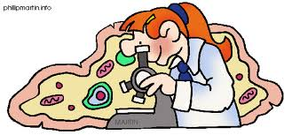
Teacher ___________Period ____

The Cell Theory
(1) Over the years, scientists have used the microscope to make discoveries. (2) In 1838, a German scientist concluded that all plants are made of cells. (3) The next year, Theodor Schwann concluded that all animals are also made of cells. (4) In 1855, a German doctor, Rudolf Virchow proposed that new cells are formed only from existing cells. (5) The observations and conclusions of these scientists and others led to the development of the cell theory. (6) The cell theory states that all living things are composed of cells, cells are the most basic unit of life, and all cells come from preexisting cells. (7) All cells have organelles (structures within the cell) that perform particular functions. (8) All organisms are either unicellular (made of only 1 cell) or multicellular (made of more than 1 cell).

1. In the space provided, create a graphic organizer that organizes the 3 major tenets (ideas) of the cell theory. Include illustrations to explain each idea of the theory.

2. Differentiate between a unicellular organism and a multicellular organism.
____________________________________________________________________________________________________________________________________________________________________________________________________________________________________________________________________________________________________________________________________________________________
________________________________________________________________________________________________________________________________________________________________________________________________________________________________________
________________________________________________________________________________________________________________________________________________________________________________________________________________________________________
________________________________________________________________________________________________________________________________________________________________________________________________________________________________________
________________________________________________________________________________________________________________________________________________________________________________________________________________________________________
________________________________________________________________________________________________________________________________________________________________________________________________________________________________________
________________________________________________________________________________________________________________________________________________________________________________________________________________________________________
________________________________________________________________________________________________________________________________________________________________________________________________________________________________________
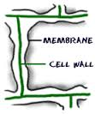
Cell Wall
(1) The cells of plants, algae, fungi, and most bacteria are enclosed in a cell wall. (2) Cell walls are tough, rigid, outer coverings that provide a protective framework for the cell. (3) It is made mostly of a substance called cellulose that form long, thread-like fibers. (4) These fibers form a thick mesh that allows water and other materials to pass through it.

1. Pretend that you are a water molecule entering a plant cell. Construct a paragraph describing your adventure. (Hint: Plant cells have cell walls and cell membranes.) Be specific by including details that are supported by the text.
________________________________________________________________________________________________________________________________________________________________________________________________________________________________________

2. Create 2 questions that could be answered by reading the text above. Include the answers.
Question: ____________________________________________________________________________________________________________________
Answer:
____________________________________________________________________________________________________________________
Question:
____________________________________________________________________________________________________________________
Answer:
____________________________________________________________________________________________________________________

Venn Diagram
Directions: Complete the Venn Diagram by comparing plant and animal cells. Label the circle plant cell and label the box animal cell.

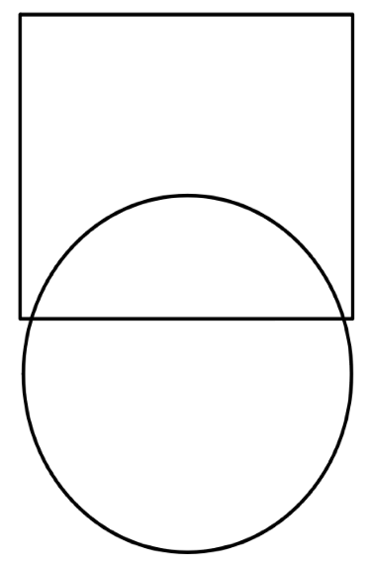

_
________________________________________________________________________________________________________________________________________________________________________________________________________________________________________
________________________________________________________________________________________________________________________________________________________________________________________________________________________________________
________________________________________________________________________________________________________________________________________________________________________________________________________________________________________
________________________________________________________________________________________________________________________________________________________________________________________________________________________________________
________________________________________________________________________________________________________________________________________________________________________________________________________________________________________
________________________________________________________________________________________________________________________________________________________________________________________________________________________________________
________________________________________________________________________________________________________________________________________________________________________________________________________________________________________
________________________________________________________________________________________________________________________________________________________________________________________________________________________________________

Cell Membrane
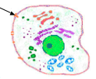
(1) The cell membrane is a thin, flexible outer covering of a plant and animal cell. (2) The cell membrane regulates interactions between the cell and the environment by allowing substances to move in and out of the cell. (3) For example, water can move freely in and out of the cell through the organelle. (4) Molecules of sugar enter and waste products leave through this organelle through a process called diffusion. (5) Materials move from an area of higher concentration to an area of lower concentration. (6) Osmosis is the diffusion of water across the membrane.

1. Summarize the functions of the cell membrane using evidence from the text.
______________________________________________________________________________________________________________________________________________________________________________
2. Create a labeled diagram that illustrates the process of diffusion and a second diagram that illustrates osmosis.

3. Explain how diffusion and osmosis ensure the survival of a cell.
______________________________________________________________________________________________________________________________________________________________________________

4. Imagine that you were a cell without a cell membrane. Explain how this would impact your life as a cell.
____________________________________________________________________________________________________________________
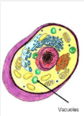
Vacuoles
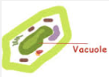
(1) Vacuoles are storage bubbles found in plant and animal cells. (2)Vacuoles store food, water or any variety of nutrients a cell might need to survive. (3) They can even store waste products so the rest of the cell is protected from contamination. (4) Eventually, those waste products would be sent out of the cell. (5) Animal cells have more vacuoles than plant cells and animal cell vacuoles are much smaller. (6) Plant cells have larger vacuoles and fewer than animal cells, sometimes having only 1 vacuole that can take up 80% of the cell. (7) Plant cells need to store more water and if the plant doesn’t have enough water, the vacuoles will shrink causing the plant to wilt.

1. Compare the role of the vacuoles in the plant cell and the vacuoles in an animal cell. Be sure to include how they are alike and how they are different.
____________________________________________________________________________________________________________________
______________________________________________________________________________________________________________________________________________________________________________

2. Illustrate a plant cell that has enough water and illustrate a plant cell that doesn’t have enough water.

3. Explain the relationship between osmosis and diffusion and the vacuoles in plant and animal cells. You may write an explanation or draw a model. Be sure to include captions and labels that further explain your model.

Plant Cell
Directions: Draw and label the following parts the appropriate color.
Cell Membrane- Red Cell Wall- Orange
Vacuoles- Blue Nucleus- Purple
Cytoplasm- Yellow Lysosomes- Brown
Chloroplasts- Green Mitochondria- Sky blue
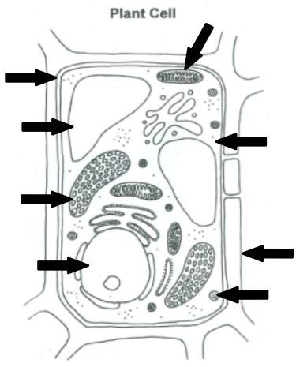
Animal Cell
Directions: Draw and label the following parts the appropriate color.
Cell Membrane- Red Nucleus- purple
Vacuoles- Blue Lysosomes- Brown
Cytoplasm- Yellow Mitochondria-sky blue

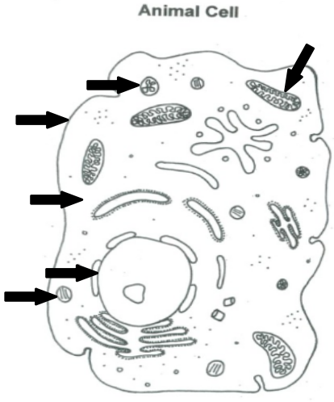

Cytoplasm
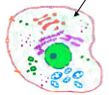
(1) Inside every cell is a gelatin-like material called cytoplasm that is made mostly of water. (2) All of the organelles are embedded in the cytoplasm. (3) Cytoplasm is similar to seawater which is why our bodies need water and some salt. (5) We have to maintain the right amount of water and salt within our cells. (6) Cytoplasm is essential for metabolism (all of the cellular chemical reactions that are necessary for life). (7) Some cells undergo chemical reactions to produce food and all cells undergo chemical reactions to produce energy. (8) Most of a cell’s life processes occur in the cytoplasm.

1. Summarize the function of the cytoplasm using evidence from the text.
______________________________________________________________________________________________________________________________________________________________________________
2. Applying what you learned about the cytoplasm, generate an example of a real- world item that performs a similar function. Explain how your item’s function is similar to the function of the cytoplasm.
______________________________________________________________________________________________________________________________________________________________________________
3. Explain metabolism.
______________________________________________________________________________________________________________________________________________________________________________
4. Create a picture or comic that illustrates how the cytoplasm depends on the cell membrane AND how this ensures the survival of the cell.

Mitochondria/Mitochondrion
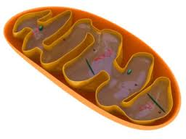
(1) The energy in food is stored until it is released by the mitochondria through a process called respiration. (2) The mitochondria are known as the “powerhouse” of the cell because they are the energy-producing sites of the cell. (3) The energy is used for cellular growth, repair, reproduction and other processes. (4) Cells that are more active have more mitochondria (i.e.- muscle cells). (5) All organisms break down simple sugar (C₆H₁₂O₆) into carbon dioxide (CO₂) and water (H₂O) to release energy.
Respiration Equation:
C₆H₁₂O₆ + 6O₂ 6CO₂ + 6H₂O + energy

*Mitochondria- plural *Mitochondrion- singular

1. Develop an argument based on evidence from the text to support the following statement. The mitochondrion is similar to Duke Energy.
____________________________________________________________________________________________________________________
__________________________________________________________
2. Determine if the respiration equation supports the law of conservation of matter. Show your work and explain your final answer.

3. Illustrate and label the respiration equation.

4. Examine the photosynthesis and respiration equation carefully. Write a comparison of the two equations. Be sure to include similarities and differences.
____________________________________________________________________________________________________________________

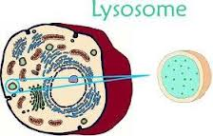
Lysosomes
(1) Has anyone ever asked you to take out the trash? (2) You probably did not consider that action as part of a team effort, but in a cell, it is. (3) Inside a cell, numerous organelles function to remove wastes. (4) One of the key organelles involved in digestion and waste removal in all cells is the lysosome. (5) They digest excess or worn out organelles, food particles, waste not needed for cellular metabolism, and engulfed viruses or bacteria. (6) Lysosomes are like the stomach of the cell.

1. Suppose an organism contracted a disease that affected the lysosomes of the cell. Based on the text, draw a conclusion about what would happen within the cells if the lysosomes were not functioning properly.
________________________________________________________________________________________________________________________________________________________________________________________________________________________________________

2. Create a labeled illustration that depicts a lysosome as a superhero. Include in the illustration how the lysosome works to ensure the survival of cells.

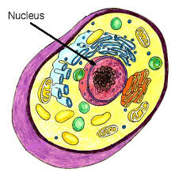
Nucleus
(1) The nucleus directs all cell activities and is separated from the cytoplasm by a membrane. (2) Materials enter and leave the nucleus through openings in the membrane in both plant and animal cells. (3) The nucleus contains the instructions for everything the cell does. (4) The nucleus also contains the DNA (genetic material that contains the code for the cell’s structures and activities) for the organism and is found in plant and animal cells. (5) Cellular reproduction begins in the nucleus of the cell and occurs when cells make copies of all of their parts to form new cells.

1. Summarize the function of the nucleus.
____________________________________________________________________________________________________________________
____________________________________________________________________________________________________________________

2. Predict what would happen to a cell if the nucleus were damaged and unable to function properly.
____________________________________________________________________________________________________________________
____________________________________________________________________________________________________________________

3. Create a model that illustrates the role that the nucleus plays in the survival of a cell. The model needs to include labels and/or captions to explain.

Chloroplasts
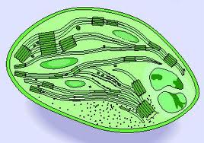
(1) In plant cells, food is made through photosynthesis in the chloroplasts. (2) Chloroplasts contain the green pigment chlorophyll that gives plants a green color and absorbs light energy from the sun. (3) During the process of photosynthesis, plants use light energy (sunlight), carbon dioxide (CO₂), and water (H₂O) to make glucose, a simple sugar (C₆H₁₂O₆), and oxygen gas (O₂). (4) The O₂ is released into the atmosphere as a waste product and the C₆H₁₂O₆ is used to make energy for the cell.
Photosynthesis Equation:
6CO₂ + 6H₂O + energy C₆H₁₂O₆ + 6O₂

1. Summarize the process that occurs in the chloroplasts of plant cells.
____________________________________________________________________________________________________________________
____________________________________________________________________________________________________________________
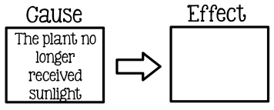
2. Complete the cause and effect model. Be sure to be specific and relate your response to the text.
____________________________________________________________________________________________________________________
____________________________________________________________________________________________________________________
3. Determine if the photosynthesis equation supports the law of conservation of matter. Show your work and explain your final answer.
____________________________________________________________________________________________________________________
4. Illustrate and label the photosynthesis equation.

