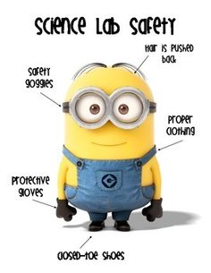
Lab Safety Rules

- Horseplay, running, or playing around will not be tolerated.
- Follow all written and verbal directions carefully, ask the teacher if you have questions.
- Don’t touch any equipment, or supplies without permission.
- Perform only approved experiments.
- Never eat, drink, or taste anything in science room.
- Keep hands away from face, eyes and mouth when working with science materials and chemicals. Wash hands when you leave.
- Wear safety glasses or goggles when instructed.
- Keep work area neat and clean.
- Clean all work areas and equipment at the end of the experiment.
- Report all accidents, injuries or spills to the teacher.
- Dispose of waste by following teachers directions.
- Consider all chemicals to be dangerous, don’t smell, touch, or taste any chemicals.
- Handle all animals with care and respect.
- Carry a microscope with 2 hands-one on the arm, the other on the base.
- Never open storage cabinets or prep room without permission from the teacher.
- Handle all glassware with care. Never pick up broken or hot glassware with bare hands.
- Use extreme caution when using matches, a burner or a hotplate.
- Dress properly-tie back long hair, no dangling jewelry, and no loose or baggy clothing. Wear aprons when instructed.
- Learn where the safety equipment is, and know how to use it. Know where the exits are. 